**MUHAMMAD MUSTHOFA BASYEER ZULKIFLI**

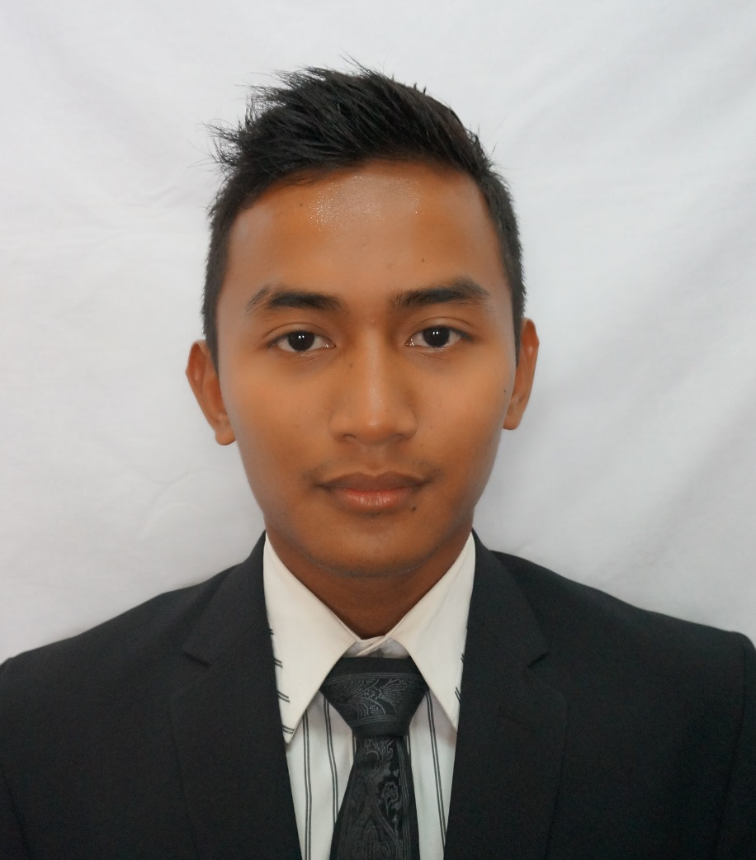

**OBJECTIVES**

* To work in a friendly environment organization and have the ability to complete a task as individual also with the team.
* To utilize my skills, abilities and experiences in the best possible way for achieving company’s goals.
* To gain more knowledge in other field.

**PERSONAL PARTICULAR**

Address : 54,Jalan Tanjung 1,bb7, Bukit Beruntung 48300 Rawang, Selangor

Date of Birth : 24th April 1993

Contact No : 012-3861537

Email : [Basyeerzulkifli@gmail.com](mailto:Basyeerzulkifli@gmail.com)

Nationality : Malaysian

**ACADEMIC QUALIFICATION**

2012 – Present : University Teknologi Mara (UiTM) Shah Alam, Selangor, Malaysia

Bachelor of Engineering (HONS) Electrical

Current CGPA : 3.02

2011 – 2012 : Johor Matriculation College , Tangkak, Johor,Malaysia

CGPA : 3.51

2010 – 2011 : Giatmara Hulu Selangor, Kolumpang, Selangor, Malaysia

Certificate of Automotive

CGPA : 4.00

**WORKING EXPERIENCE**

**Sempurna Phone Studio**

Position Title : Branch Manager

Duration : March – August 2012

Specialization : Sales and Management

Work Description : Performed sales and promotion of goods

: Manage a company’s account and stocks.

**LANGUAGES**

Proficiency

Beginner 1

Intermediate 5

Excellent 10

Spoken Written

Malay 10 10

English 6 6

Arabic 5 5

**SKILLS & AREAS OF EXPERTISE**

Proficiency:

Advanced (10) – Highly experienced

Intermediate (5) – Familiar with all basic functionalities

Beginner (1) – Just started using

Photoshop 7 Physical Training 8

Microsoft Office 8 Multitasking 8

Sony Vegas Pro 12 5 Critical Thinking 8

PSIM 7.1.2 5 Teamwork 8

PSS Adept 3 Fast Learner 8

**EXTRA CO-CURRICULUM ACTIVITIES**

2012 – 2015 : Reserve Officer Training Unit ( ROTU )

* Participated in Annual Camp Training (ACT) I at KDSK, Klang , Selangor.
* Participated in ACT II and ACT III at KDSI 1 ,Lumut , Perak.

: Committee for `Bon Voyage a Lima 2015’.

: Committee for `Inter Navy Sport Carnival 2013’.

: Committee for `Team Building Siri 3’ at Tasik Kenyir,Terengganu.

: Director for `Fitness Test Program’ at UiTM Shah Alam,Selangor.

: Participate in sailing program `Voyage 323/15’.

: Participate in `Navy Sport Carnival’

: Participate in `UiTM Night Run 2014’.

: Participate in `Wellness X 14’.

: Participate in `Beach Cleaning Program’ at Pulau Perhentian, Terengganu.

**ACHIEVEMENT**

2012 – 2015 : Gold medallist for volleyball in men category in `Navy Sport Carnival 2012’.

: Silver medallist for street soccer in men category in `Navy Sport Carnival 2013’.

: Silver medallist for volleyball in men category in `Navy Sport Carnival 2013’.

: Bronze medallist for street soccer in men category in `Inter Navy Sport Carnival 2013’.

: Gold medallist for hockey deck in men category in `Navy Sport Carnival 2014’.

: Second Place for Street Soccer in men category in `Sukan Fakulti Elektrik 2014’

: Leader of white watch in sailing program.

**REFERENCES**

Dr. Zuhaila binti Mat Yasin Dr. Hasmaini binti Mohamad

Head of Programme Lecturer

Faculty of Electrical Engineering Faculty of Electrical Engineering

Universiti Teknologi Mara (UiTM) Universiti Teknologi Mara (UiTM)

40450 Shah Alam, Selangor 40450 Shah Alam, Selangor

Tel: 03-55435109 / 013-3055431 Tel: 03-44536084

Email: [zuhai730@salam.uitm.edu.my](mailto:zuhai730@salam.uitm.edu.my) Email: hasmaini@salam.uitm.edu.my